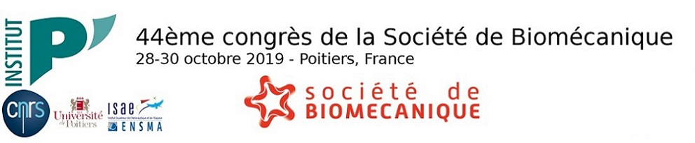
SPONSORSHIP PROGRAM - Lunch

To apply you must be a member of the Société de Biomecanique.

- Title: Choisissez un élément.
- First Name:
- Last Name:
- Position:
- Institution:
- E-mail adress (recommanded):
- Abstract title :
Accepted for: Oral presentation Poster presentation

Please attach the documents below:
- A cover letter (maximum 1 page)
- A short CV (maximum of 1 page)
- Summary of your research topic (maximum 1 page)
- A copy of the abstract submitted to the Congress

Please complete and send your application to :
khalil.ben-mansour@utc.fr

