I- Membership information
Title: Choisissez un élément.
First Name:
Last Name:
Date of birth:
Position:
Department:
Institution:
Institution website:
E-mail adress (recommanded):
Are you available as a mentor? Yes NO

Made in , on ,
Signature
Click in the picture to insert your signature

Membership dues
Student membership fees : 20 €
Other person membership fees : 40 €

The normal method for paying SB membership fees is by bank transfer. Please find the Socité de Biomécanique IBAN at the end of this application form.

II- Activity in biomechanics
Qualification

Field of Interest
Biomaterials and tissue engineering
Cardiovascular and respiratory biomechanics
Cellular and tissue biomechanics
Impact biomechanics
Bone and joint biomechanics
Musculoskeletal and movement analysis
Sports biomechanics
Ergonomics, handicap and rehabilitation
Humanoid robotics

Do you belong to other scientific societies? Yes NO
Please specify:

Please complete and send this form to the following email address:
khalil.ben-mansour@utc.fr

Président : V. Deplano IRPHE CNRS UMR 7342, Université d’Aix-Marseille
Vice-Président : S. Laporte IBHGC – Ecole Nationale Supérieur d’Arts et Métiers
Trésorier Adj. : K. Ben Mansour Université de Technologie de Compiègne
Secrétaire Général : F. Colloud Institut Pprime UPR 3346 (CNRS, Université de Poitiers, ISAE-ENSMA)

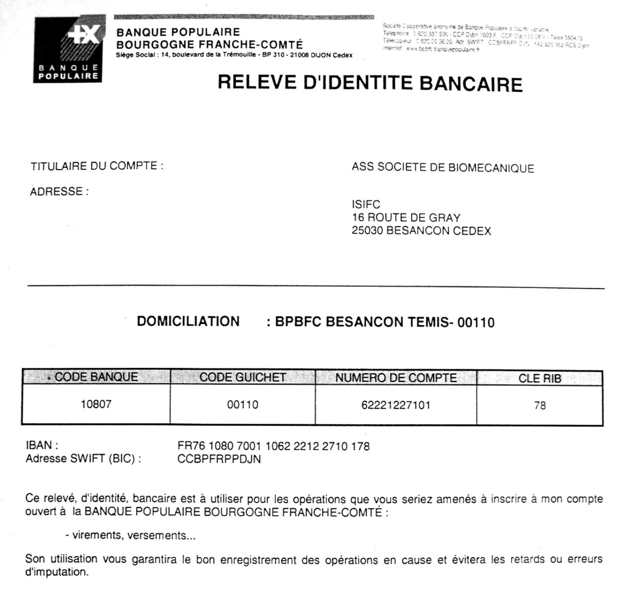
N° de SIRET 49275528500011

